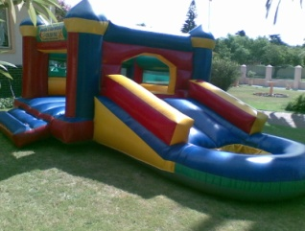
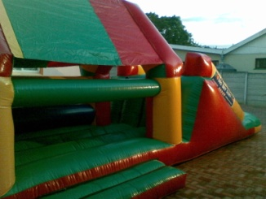
HOLLY HOP JUMPING CASTLES
082 567 3287

For GUARANTEED FUN please ensure that you have read and understand the Terms and Conditions

Play It Safe!
- Holly Hop Jumping Castles will not be held responsible for any injury or death while utilising our jumping castles.
- Holly Hop Jumping Castles are intended for children between the ages of 1 and 13 years.
- Please supervise children of all ages while utilising the jumping castle.
- Please do not allow more than six (6) children at a time on the jumping castle.082567 3287
- Please ensure that children do not play near, or with, the jumping castle motor.

Take Care of Our Castle
- The jumping castle will be set up by our personnel on grass and in the shade (no set up on cement or brick paving).
- Please ensure that enough space is available to accommodate the requested size of jumping castle.
- Please do not eat and drink on jumping castle, and do not allow shoes, sharp objects, or fire on or near the castle.
- Only use water on castles during warm summer days and take the motor indoors in the case of rain.
- Damage to the jumping castle or motor while in possession of the hirer will be payable by the hirer.

The Money Stuff!
- Deposit payments are not refundable, irrespective of the reason for cancelling by the hirer.
- Deposit payments are refundable in the case of rain, but a R50 administration fee will be withheld.
- Please enquire on the additional fee to be charged for usage by teenagers and adults.
- The hirer is responsible for replacing the jumping castle if it is stolen while in his/her possession.
- The jumping castle remains the property of Holly Hop Jumping Castles and must be returned.

